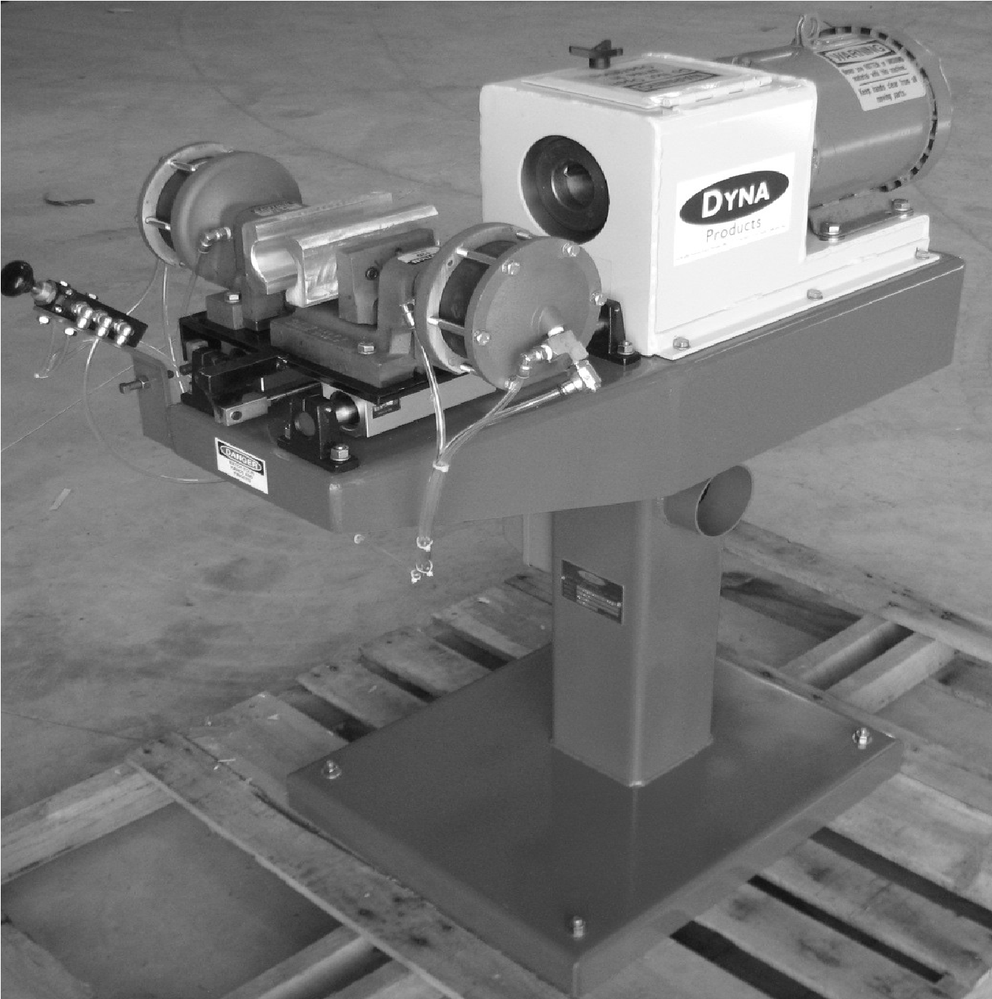
Model TM300 Mini
Tenoner / Pointer
Operator's Manual

Dyna-Bignell Products LLC
545 Industrial DR.
Clare, MI. 48617
D
YNA

WARRANTY INFORMATION
All of Dyna-Bignell Products LLC'S equipment comes with a 12 month limited warranty. If any product or part is proved to be defective 12 months from date of purchase, by reason of improper workmanship and/or material we will replace, at our discretion, that part or product at no charge to you. To obtain warranty service, the customer must deliver the part or product to the below address at their expense. A copy of the original sales invoice is required when requesting warranty work.
The above warranty does not cover defects caused by modification, alteration, or repair of the part or product in question, by anyone other than the manufacturer, physical abuse to, or misuse of, the product or use or assembly thereof in any manner contrary to the accompanying instructions.
Dyna-Bignell Products LLC
545 Industrial DR.
Clare, MI 48617
(989) 418-5050 ph.
bignellproducts@gmail.com Email
www.dynabignell.com Website

SAFETY
It is the operator's responsibility to keep him/herself and others away from the machine while it is running. This machine , if not properly maintained and operated can cause injury and/or death.
Always use appropriate face, eye, ear, hand and body protection when operating this machine.
Never place log inside rotating cutter head without clamping.
Always keep body parts away from clamp and any moving parts of machine. Confirm rotation of cutter head before startup.
Check for loose nuts, bolts, cutter head, bearings, pulleys etc before startup daily. Always log your maintenance and safety checks.
Never tenon logs shorter than 16” in length.
Always lockout electrical and air power before servicing machine.
Always keep guards installed while machine is in motion.
Apply a minimum of 120 psi air pressure to the TM300 and have regulator adjusted no less than 70 psi. You may increase this if material spins or lips in clamp.
NEVER OPEN THE CLAMP WHILE LOG IS INSIDE CUTTER HEAD. INJURY OR DEATH CAN OCCUR.

OPERATION
Place material into clamp and even with the open of the cutter guard. Press foot switch. Clamp should close and then traverse the material into cutter head. Releasing the foot switch causes material to reverse and the clamp opens upon contact with homing valve.
Use supplied forked bar to pry cutter off shaft if removing.

Control Schematic

FRL
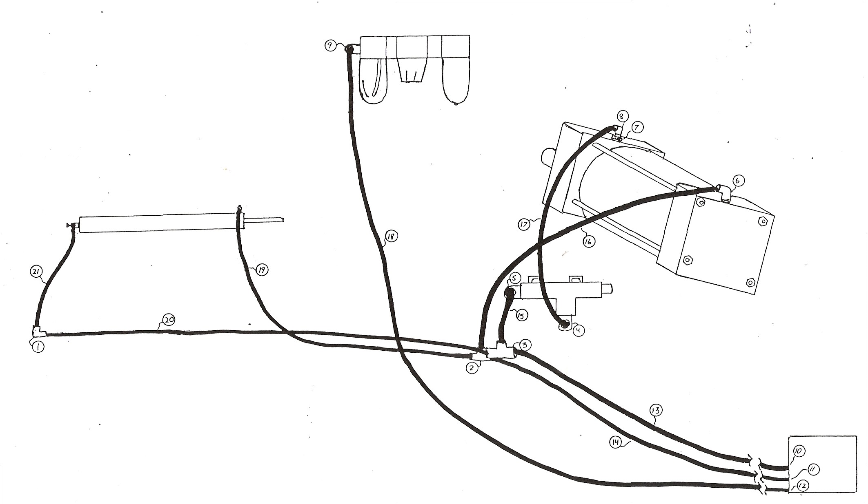
Foot Valve
Clamp Cylinder
(2
actual
)
Feed Cylinder
(
filter-regulator-lubricator
)
Homing Valve
NOTE:
Some versions include a palm valve to operate the cycle.

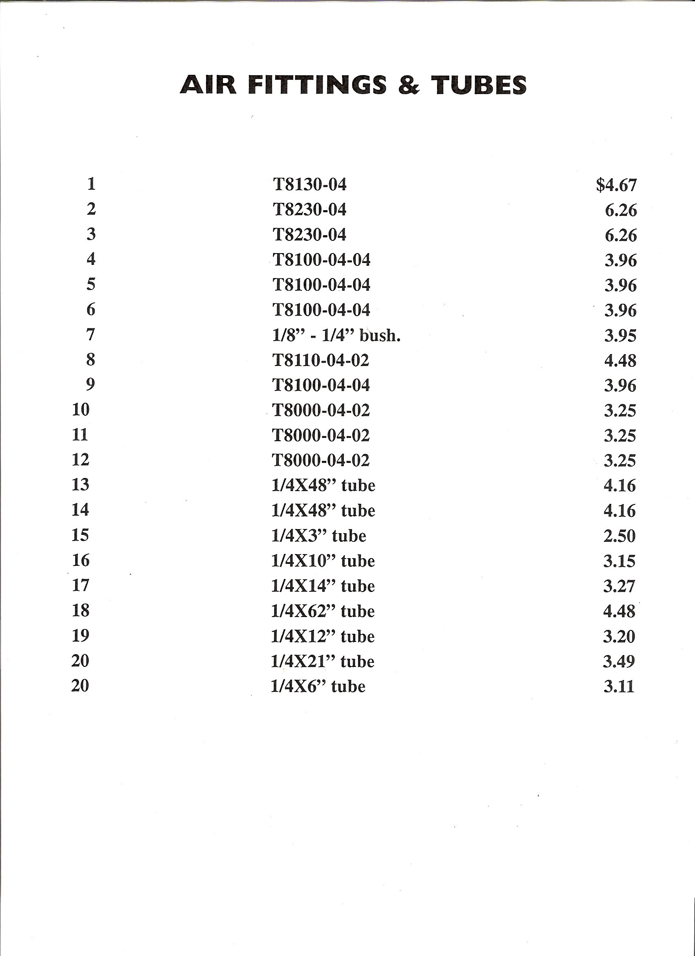

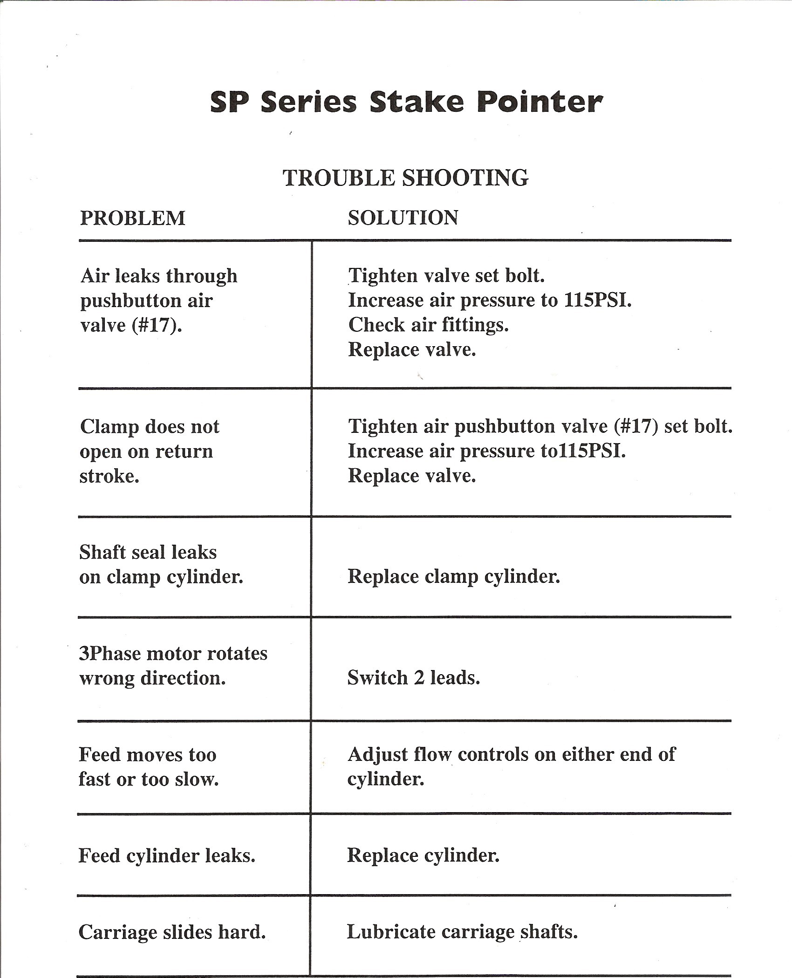
TM300 MINI-TENONER
Dyna-Bignell Products LLC
545 Industrial Dr.
Clare, MI. 48617
(601) 418-5050 PH.
bignellproducts@gmail.com Email
www.dynabignell.com Website

